**PROJECT-NAME: MIVI (e-commerce)**

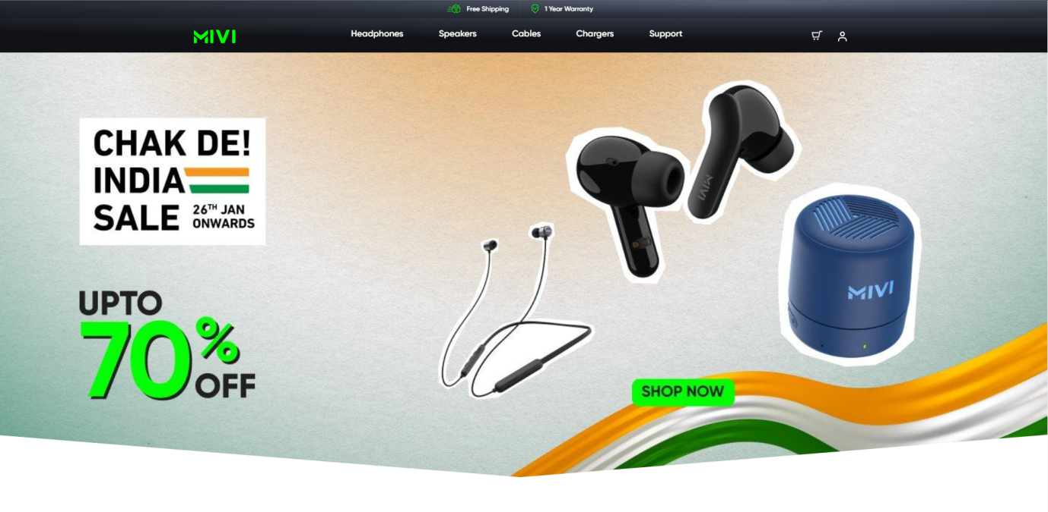

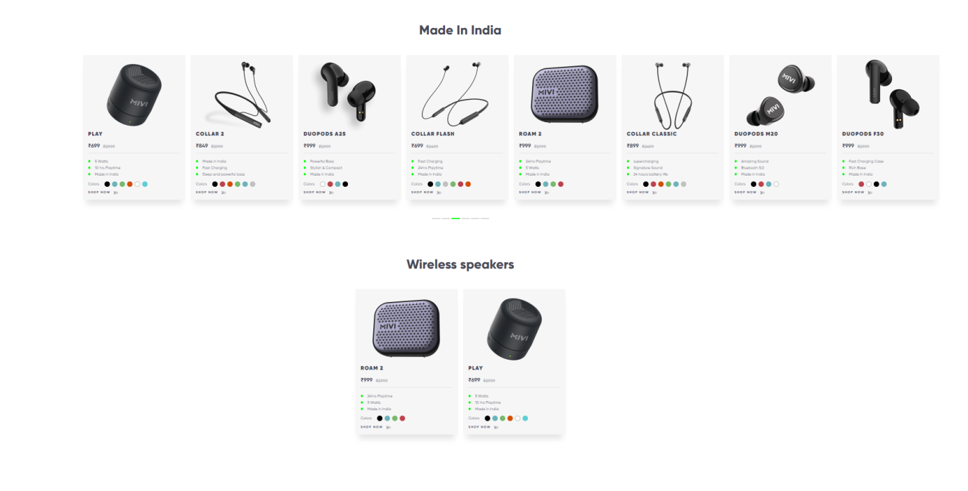

**\*OVERVIEW:**

It’s an e-commerce website for electronic devises, from headphones to TWS and speakers everything is available under the same roof.

1. **HOME PAGE:**

# LOGO

# ICONS - (ADD TO CART, LOGIN)

# SEARCH BAR

# SLIDERS WITH ARROWS - (IMAGES)

# DEALS - (IMAGES)

# FEATURED - (IMAGES)

# TRENDING - (IMAGES)

# FOOTER – (CONTACT US , HELPLINES , BRIEF DESCRIPTION ,ABOUT THE COMPANY , SOCIAL-MEDIA HANDLE, ICONS , LINK TO MOBILE APP )

1. **LOGIN FORM:**

# Mobile Number > OTP > account page

**3. MAIN PAGE:**

**# FILTERS** –

(COLOR , DISCOUNT RANGE , PRICE ,

MATERIAL , FEATURES , OCCASION , PATTERN ,

RATING , SIZE , TYPE , SORT BY: )

**# IMAGES OF THE CHOSEN PRODUCT WITH DETAILS LIKE -**

( PRODUCT NAME , PRICE , FEATURES , DISCOUNT%

(IF ANY ) )

**# PRODUCT DESCRIPTION –**

( PRODUCT NAME , COLOR ,RATINGS , PRICE , DISCOUNT% (IF ANY) , DELIVERY DETAILS ,

` PRODUCT, SPECIFICATIONS , CUSTOMER REVIEWS

WITH IMAGES (IF ANY ) )

**# LOWER HALF OF THE PAGE -**

( PRODUCT SPECIFICATIONS )

**4. PAYMENT PAGE:**

**# ADDRESS SELECTION**

**# PAYMENT METHOD –**

(PHONEPE , GOOGLE PAY , BHIM UPI , COD , CREDIT/DEBIT CARD , NET - BANKING , EMI , PAYTM)